Treatment of Tinnitus with Noninvasive Neuromodulation and Listening Therapy

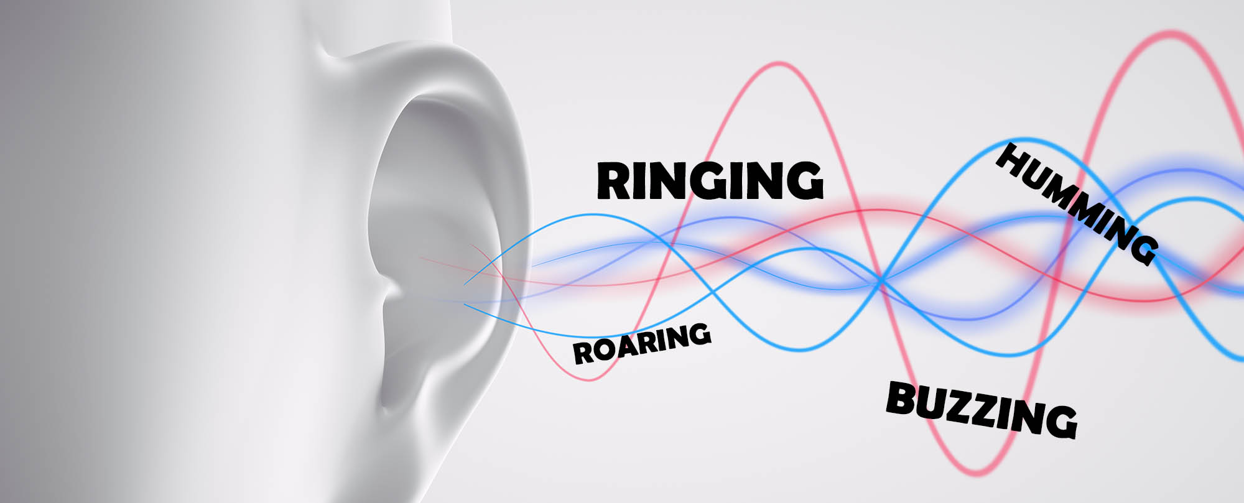

Study Participants Needed
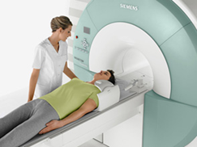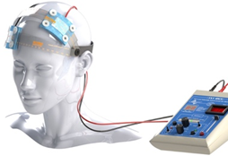

We are looking for volunteers who experience tinnitus to participate in a research study that investigates therapeutic effects of noninvasive brain stimulation and listening therapy

Why is the study being conducted?
Researchers at the University of Arizona in the Department of Speech, Language, and Hearing Sciences are conducting a study that examines treatment of tinnitus (ringing in the ears) with non-invasive brain stimulation combined with listening therapy.

What is involved?
Participation will involve hearing assessment, tinnitus assessment, Transcranial Direct Current Stimulation (tDCS) sessions with listening therapy, structural and functional Magnetic Resonance Image (MRI), and electroencephalography (EEG) exam.

Compensation

Compensation is available

To find out more please contact:

Dr. Aneta Kielar at 520-621-5105
Or email: brainarizona@gmail.com
Please write “TDCS study” in the subject line
An Institutional Review Board responsible for human subjects research at The University of Arizona
reviewed this research project and found it to be acceptable, according to applicable state and federal regulations
and University policies designed to protect the rights and welfare of participants in research.

